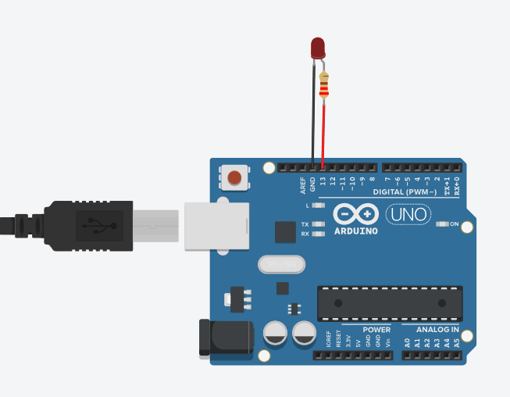

void setup() {

pinMode(13, OUTPUT);

}

void loop(){

digitalWrite(13, HIGH); delay(1000);

digitalWrite(13, LOW); delay(1000);

}